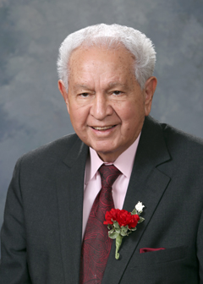
Nick L. Salazar

Nick L. Salazar served as a New Mexico State Representative from 1973-2018. Representative Salazar is a highly respected member of the New Mexico State Legislature. In his tenure, he represented District 40 which includes the counties of Colfax. Mora, Rio Arriba and San Miguel.

Representative Salazar has been a Board Member and President of the North Central New Mexico Economic Development District (NCNMEDD) for over 50 years. Under his leadership, the NCNMEDD as part of the Council of Governments had expanded the oversight of Senior Citizen’s Centers and Programs for older adults to 32 counties within the state through Non-Metro Area Agency on Aging. Within the Legislature and ‘Aging Network’, he is best known as the Champion for funding and services in support of Older New Mexicans.

In 2004 Representative Salazar sponsored the Legislation elevating the State Agency on Aging to the Cabinet level Aging and Long-Term Services Department. At that time our Governor, Michelle Lujan Grisham became the first Secretary of the Aging and Long-Term Services Department.

In addition to advocating for older adults in New Mexico, Representative Salazar has continued to model the importance of culture and tradition throughout the state. A resident of Ohkay Owingeh Pueblo, his life experience in native culture is valued and recognized within the Native communities and among all cultures.

