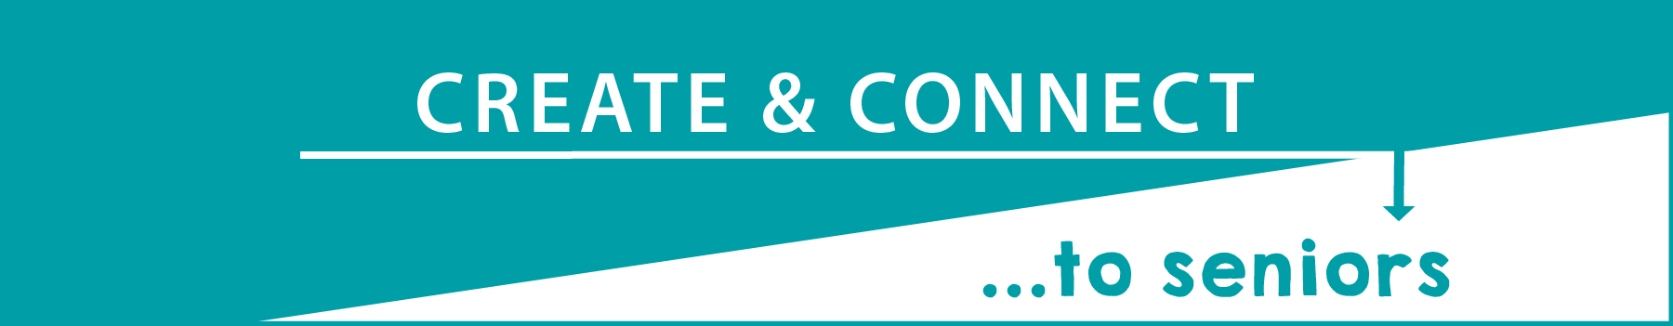
Join us in a campaign to create and connect with seniors and New Mexicans living with disabilities and seniors across the state. We’re all in this together and we want them to know they’re in our hearts and minds!
Broadcast or Stream It
Read your letter or take a picture of it and use the hashtag #CreateAndConnect
We will then share your videos and photos with people across the state. Don’t forget to challenge your friends, neighbors, classmates and community to do the same!
Send it
Your letter will be added to food boxes we’re delivering across the state and sent to nursing homes. Please see the guidelines for instructions before writing and mailing your letters. Include your return address and your pen pal may write you back.
Mailing Address:
ALTSD
Create and Connect Campaign
8500 Menaul Blvd. NE, Suite B-350
Albuquerque, NM 87112
Letter Writing Guidelines.
- Wash hands before you make your art/letter/craft.
- It will need to fit in a business or regular-sized envelope (not box or large envelope).
- Don’t lick the envelope, use a wet sponge or paper towel.
- You’ll need a current stamp.
- Do not use glitter.
- Letters must be legible (large print)
- Embrace creativity! Recipients love it when the letters are personal.
- Avoid politics completely and lengthily religious discussions, but it is okay to say you are praying for them.
- Share your act of kindness using our social media tag
#CreateAndConnect and please try to tag @NewMexicoAging

